Procedure for use:
CVAD LINE LOCK 10/19/18

- For use on patients with a history of IV drug use that are admitted for long term (usually) antibiotic therapy through a PICC line.
- PICC line must be saline locked. Contact PICC team ext 25759 (or page) when continuous fluids are discontinued for supply of Neuma Locks.
- Locks will be delivered to the Nurse Coordinator to lock up and secure on the unit. Page PICC team or call 25759 when additional Locks are needed.
- Neuma lock must be replaced each time you access the line for med administration or blood draws. Please coordinate access as much as possible to avoid wasting the device. Each device is about $3.50 each.
- Document in “Significant Event” when device is placed the first time.
- If tampering is evident and/or device is not intact document under “Significant Events” and notify provider.
- Any questions please contact Denise Hoffman, ext 25817 or contact through Halo or WebExchange.
- Directions for application:

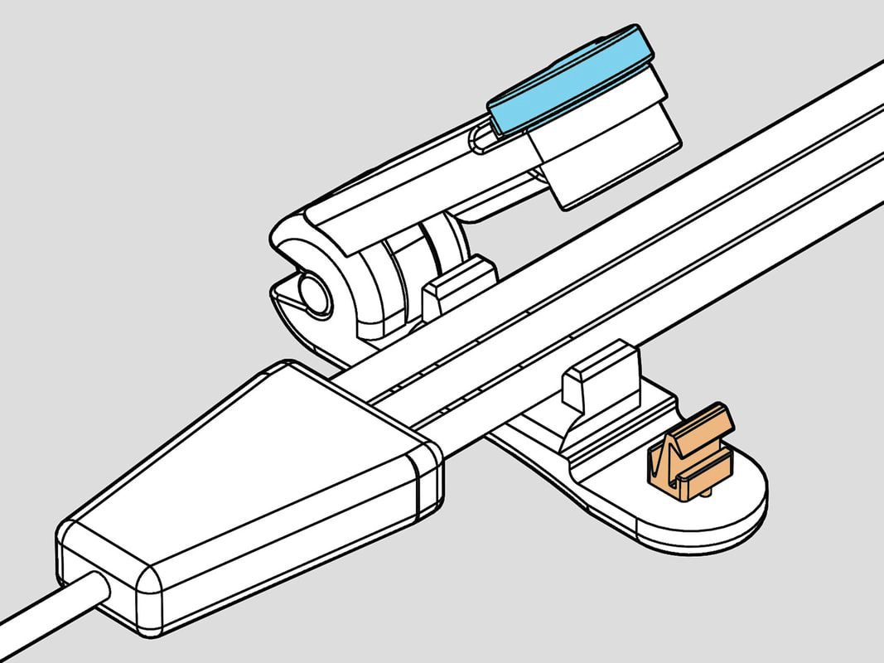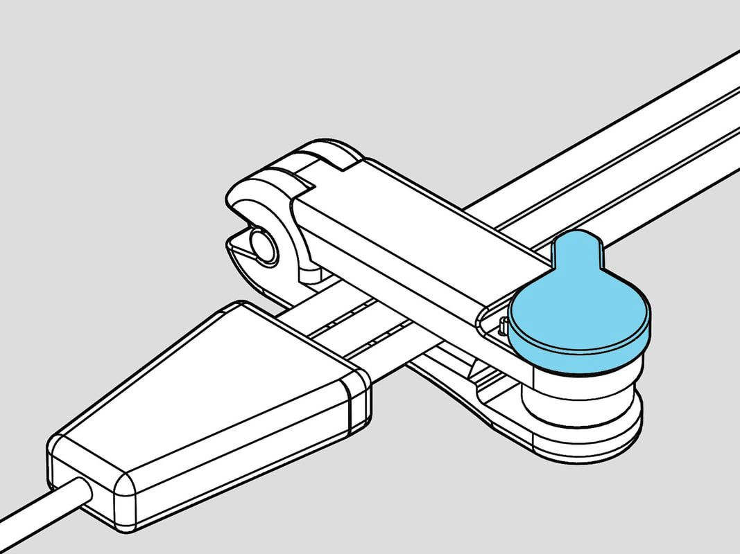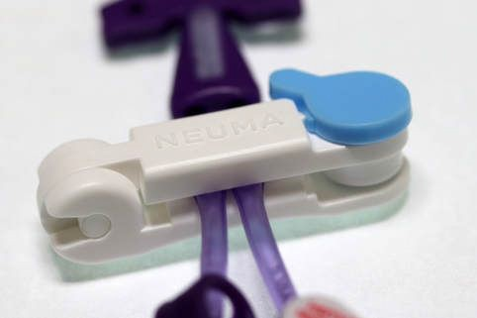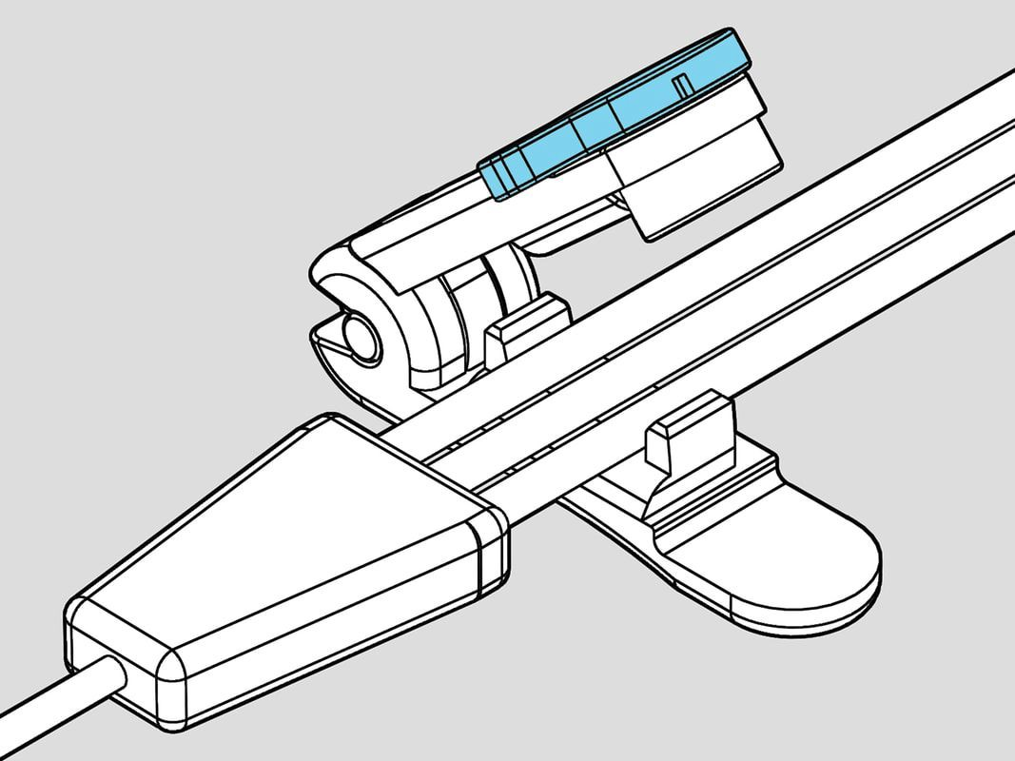

STEP ONE | STEP TWO | STEP THREE-REMOVAL
Place the lines into the | Pinch the clamp and it will | Turn blue knob to open clamp.
walled cradle.(Note the | lock shut. Now the lines are | This action breaks off the
orange hook that will hold The clamp closed.) | protected. | Orange hook and the clamp can’t be used again

